1. **Commerce Application on IBM Cloud Foundry**

**Phase 5-Project Documentation & Submission**

**Objective:**

Develop and deploy a scalable and resilient e-commerce application to enhance the online shopping experience, improve system performance, and ensure high availability for customers. The project aims to enable rapid development, continuous deployment, and effortless scalability, thereby reducing operational complexity and costs while delivering a seamless and secure shopping experience to users."This objective outlines the specific goals of the project, which include utilizing Cloud services to create a robust, scalable, and user-friendly e-commerce application. It emphasizes the importance of improved performance, high availability, and cost-efficiency, all of which are key advantages of using a cloud platform for

e-commerce applications.

**Design Thinking:**

**Platform Design:**

**Header:**

* Logo: Place the platform logo at the top-left corner for branding.
* Navigation Menu: Include links to various sections like Home, Shop, Categories, My Account, and Cart.
* Search Bar: Allow users to search for products.
* User Account: Display user login/register and profile options.

**Banner or Slideshow:**

* Showcase featured products, promotions, or artisan highlights.

**Product Categories:**

* Display a grid or list of product categories (e.g., Jewelry, Home Decor, Clothing) with images and brief descriptions.
* Each category can link to a dedicated category page.

**Individual Product Pages:**

* Product Image: A prominent image of the product
* Product Title: Display the name of the product.
* Product Description: Provide detailed information about the product, including materials, dimensions, and artisan details.
* Price: Clearly state the product's price.
* Quantity Selector: Allow users to choose the quantity they want to purchase.
* Add to Cart Button: A prominent button to add the product to the shopping cart.

**Shopping Cart:**

* Cart Icon: Show a visual representation of the cart's contents.
* Product List: List the products in the cart, including details like name, price, and quantity.
* Subtotal: Display the total cost of items in the cart.
* Continue Shopping Button: Allow users to return to product listings.
* Update Cart: Option to change quantities or remove items.
* Proceed to Checkout Button: Direct users to the checkout page.

**Checkout:**

* Order Summary: Recap of items in the cart with prices and a total.
* Payment Information: Fields for credit card details or other payment methods.
* Place Order Button: To complete the purchase.
* Order Progress Bar: Indicate the steps in the checkout process.

**Payment:**

* Secure Payment Gateway: Display trusted payment options (e.g., credit card logos, PayPal).
* Payment Form: Allow users to enter payment information securely.
* Order Confirmation: Provide an order confirmation page with details and a confirmation number.
* Order Confirmation Email: Send an email to the user with a summary of the order.

**Footer:**

* Contact Information: Include contact details, customer support links, and social media links.
* Policies: Links to terms of service, privacy policy, and return policy.
* Newsletter Signup: Option for users to subscribe to updates.
* Copyright Information: Display the copyright notice.

**Development Phases:**

The development phases for creating an e-commerce platform can be broken down as follows, encompassing both the design and implementation aspects

Phase 1: Platform Layout and Database Creation

1.1 Design Platform Layout:

* Create the e-commerce platform's user interface.
* Design the layout, navigation, and visual elements to ensure an intuitive and user-friendly experience.
* Collaborate with designers to finalize the platform's visual design.

1.2 Create Database for Product Information:

* Define the database schema to store product information, including product names, descriptions, prices, categories, and images.
* SQLITE3 database system is used.

**Setting up a Database for The Ecommerce Website**

**Step1:First Connect to SQLITE3:**

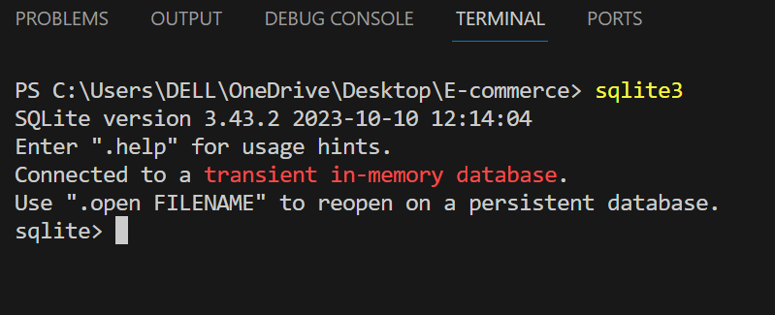

**Step2: Created a database with a name MYDB**

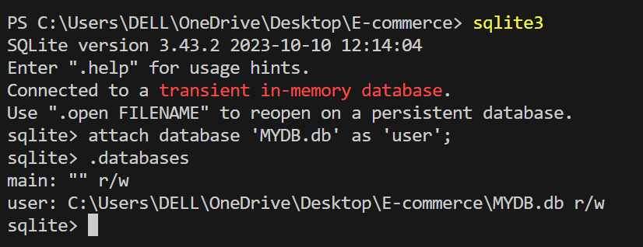

* This database created to store product and user details for my e-commerce website “Artisan treasure”.

**Phase 2: Implement User Authentication**

**2.1 User Registration:**

Develop a user registration system, allowing customers to create accounts.

Securely store user information, including usernames, email addresses, and hashed passwords.

**2.2 User Login:**

Create a login system to authenticate users when they access the platform.

Implement secure authentication practices, such as password hashing and protection against common security vulnerabilities.

**Flask code for authentication:**

**from flask import Flask, render_template, request, flash, redirect, url_for, session**

**import sqlite3**

**app = Flask(__name__)**

**app.secret_key = "123"**

**con = sqlite3.connect("MYDB.db")**

**con.execute("create table if not exists customer(pid integer primary key, name text, address text, contact text, mail text, password text)")**

**con.close()**

**@app.route('/')**

**def index():**

**logged_in = session.get("logged_in", False)**

**return render_template('index.html', logged_in=logged_in)**

**@app.route('/login', methods=["GET", "POST"])**

**def login():**

**if request.method == 'POST':**

**name = request.form['name']**

**password = request.form['password']**

**con = sqlite3.connect("MYDB.db")**

**con.row_factory = sqlite3.Row**

**cur = con.cursor()**

**cur.execute("select * from customer where name=? and password=?", (name, password))**

**data = cur.fetchone()**

**if data:**

**session["name"] = data["name"]**

**session["password"] = data["password"]**

**session["logged_in"] = True  # Flag for a successful login**

**return redirect(url_for("index"))**

**else:**

**flash("Username and Password Mismatch", "danger")**

**return render_template('login&signup.html')**

**@app.route('/register', methods=['GET', 'POST'])**

**def register():**

**if request.method == 'POST':**

**name = request.form['name']**

**mail = request.form['mail']**

**password = request.form['password']**

**cnfpassword = request.form['cnfpassword']**

**address = request.form['address']**

**contact = request.form['contact']**

**if password != cnfpassword:**

**flash("Passwords do not match", "danger")**

**else:**

**con = sqlite3.connect("MYDB.db")**

**cur = con.cursor()**

**cur.execute("insert into customer(name, address, contact, mail, password) values (?, ?, ?, ?, ?)", (name, address, contact, mail, password))**

**con.commit()**

**flash("Registration Successful", "success")**

**con.close()**

**return render_template('login&signup.html')**

**return render_template('register.html')**

**if __name__ == '__main__':**

**app.run(debug=True)**

**2.3 Shopping Cart:**

Develop a shopping cart system that allows users to add, remove, and manage items.

Implement features like quantity adjustments, total price calculation, and item details.

**2.4 Product Catalog and Selection:**

Integrate product catalog pages that display product information, images, and prices.

Enable users to browse, search, and select products to add to their shopping carts.

**2.5 Checkout Process:**

Implement a multi-step checkout process, including shipping and payment information.

Integrate payment gateways to process transactions securely.

Calculate order totals, apply discounts or promotions, and generate order summaries.

**Technology Stack Used:**

The technologies that we used for both frontend and backend are:

* + HTML
  + CSS
  + JavaScript
  + Bootstrap
  + Flask
  + Sqlite3

**Flask and Sqlite3**

Flask and IBMdb2 are used in backend to enable users for creating account and managing it securely.

**HTML, CSS, JavaScript and Bootstrap:**

Used to create an intuitive user interface with fast and responsive layout.

**Final User interface:**

**HOME PAGE:**

The Home Page of this application is the first page which visitors see when they access the site. It serves as the digital storefront and is designed to capture the user's attention. On the Home Page, you'll find a variety of elements, including:

**Newly Arrived:** These are usually displayed prominently, showcasing the best-selling or new products.

**Navigation Menu:** A menu bar or navigation links to help users easily access different sections of the website, like product categories, the shopping cart, wishlist,search bar, Loginpage.

**Search Bar**: A tool for users to search for specific products.

**Promotional Banners**: These can include sales, discounts, or any current promotions.

**Shop by Category:** An option that allows users to easily navigate and filter products by various categories, such as Kitchenware, Decor and more.

**Footer**: Contact information, links to policies, and social media links.

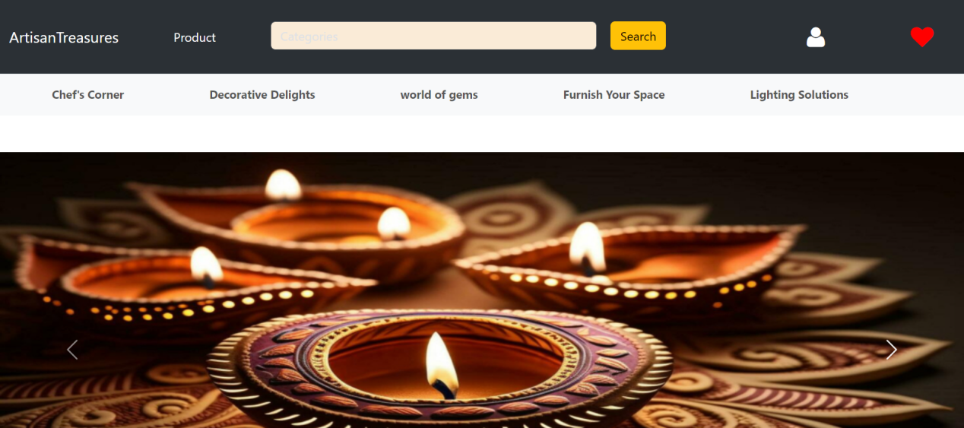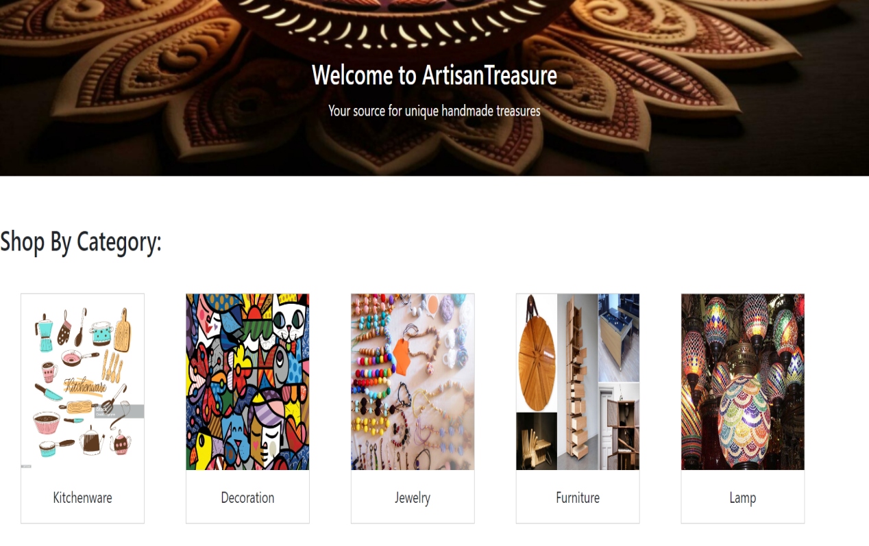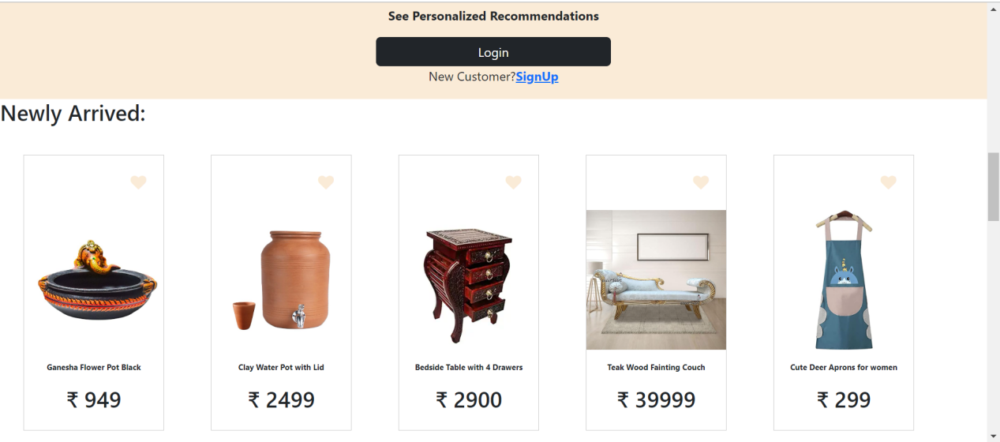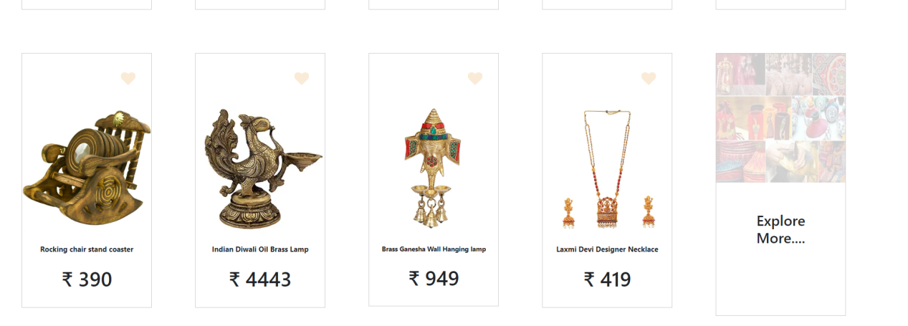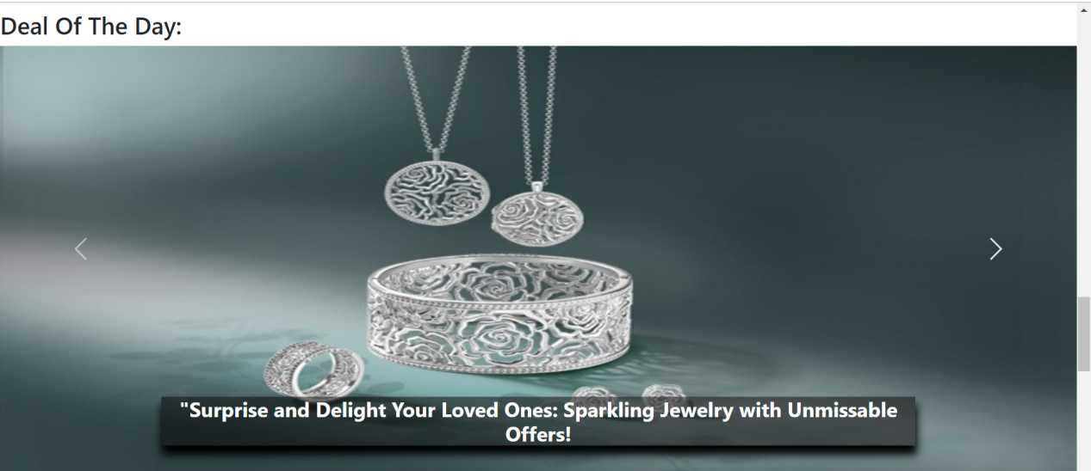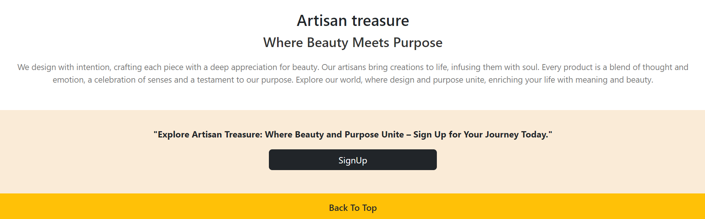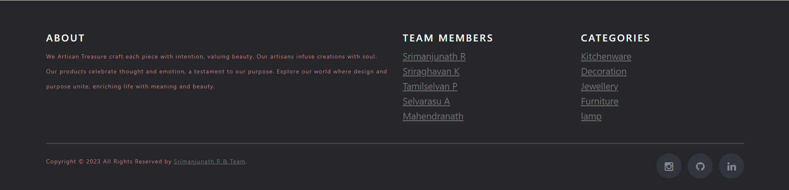

**LOGIN PAGE:**

The Login Page is where registered users log in to their accounts. It includes the following elements:

**Username/Email and Password Fields:** Users input their login credentials.

**"Remember Me" Option:** An option for users to stay logged in.

**"Create Account" or "Sign Up" Link:** For new users to register on the website.

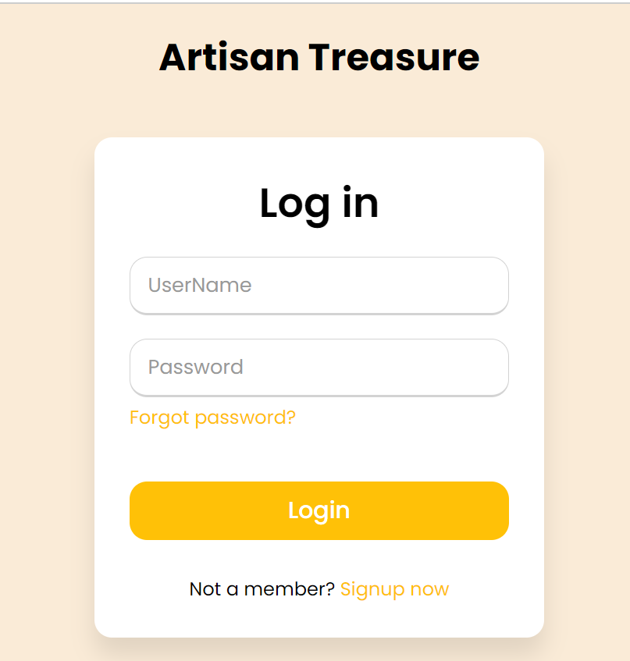

**Sign up page:**

Welcome to our Sign Up page, where you can create your account and join our community. To get started, please provide the following information:

**Name:**

Enter your full name. This will help us address you personally and make your experience more personalized.

**Email Address:**

Please enter a valid email address. We will use this to communicate with you and verify your account.

**Password:**

Create a strong and secure password. It should be at least 8 characters long and include a combination of letters, numbers, and special characters.

**Confirm Password:**

Re-enter the password you've chosen to ensure accuracy. This step helps prevent typing errors.

**Address:**

Provide your contact address. This is important for various reasons, such as shipping and location-based services.

Contact Number:

Share your contact number (optional but recommended). This will help us reach you if necessary and improve your overall experience.

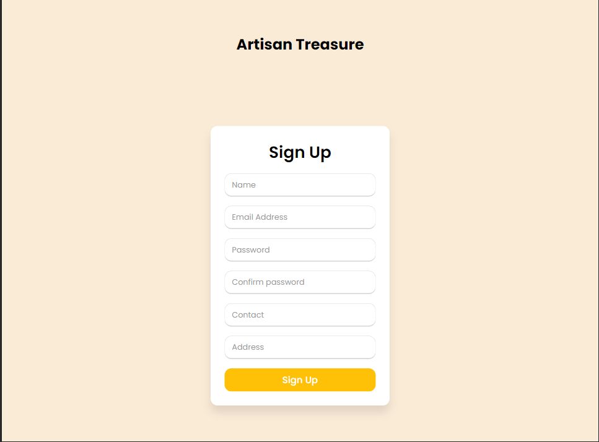

**Product pages (based on categories):**

Welcome to our product page, where you can explore our extensive range of offerings, conveniently organized by categories. Whether you're searching for specific items or simply browsing for inspiration, our user-friendly layout ensures a smooth shopping experience.

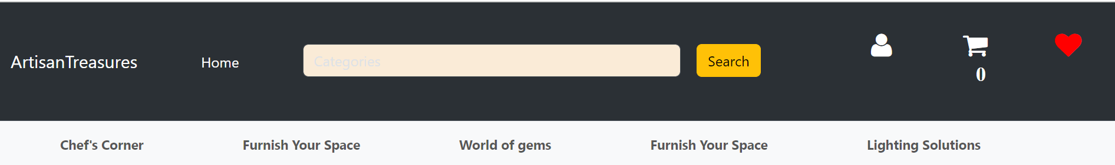

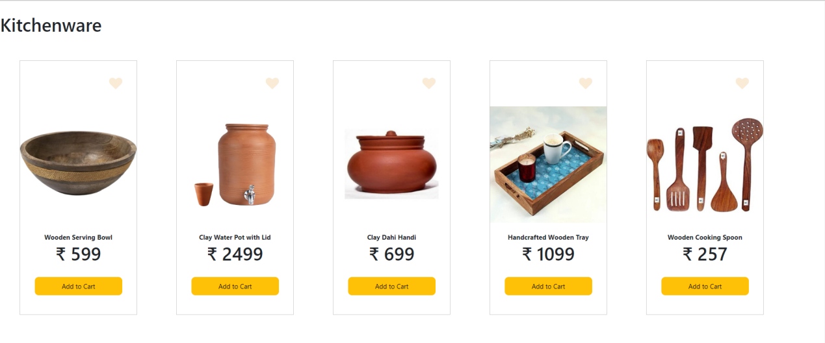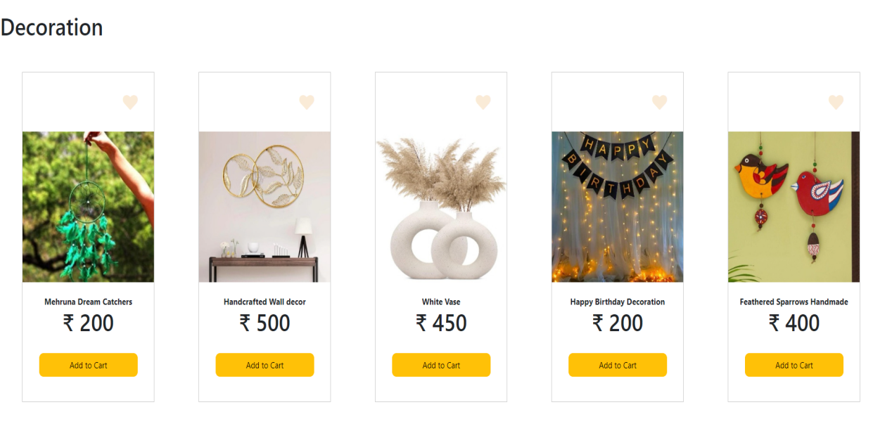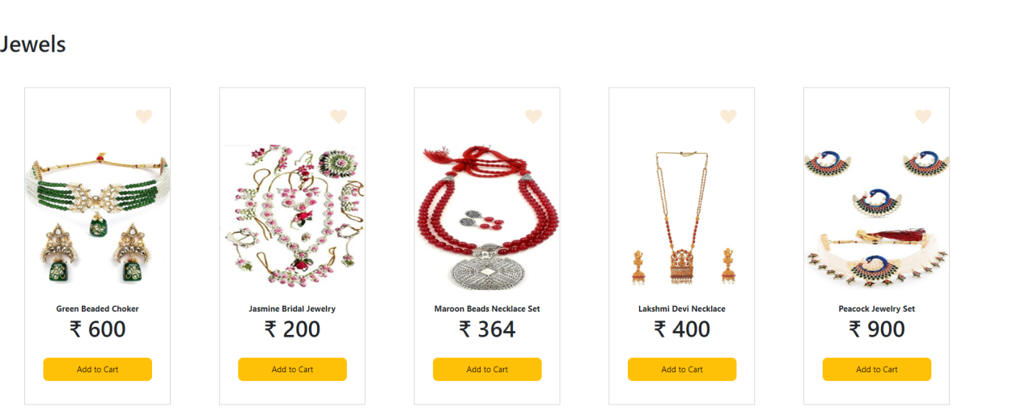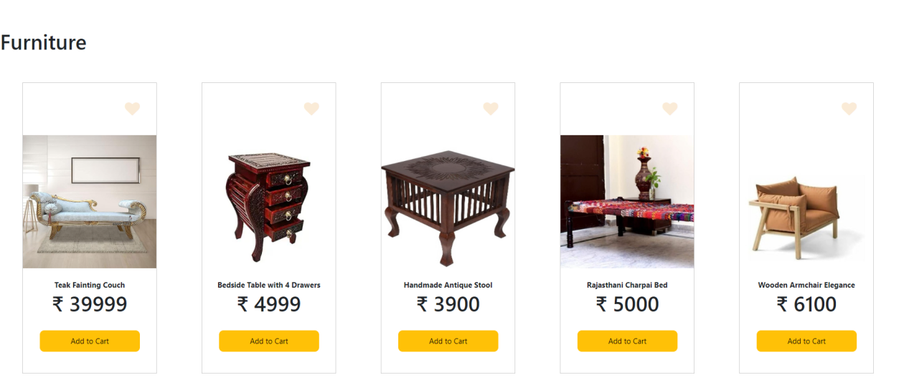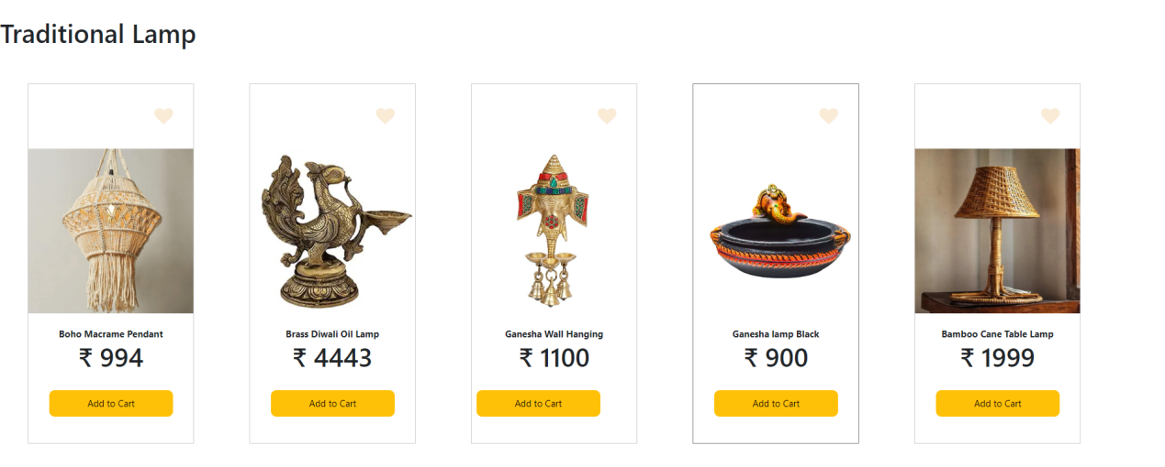

**Add to Cart:**

Click the "Add to Cart" button to collect items for purchase.

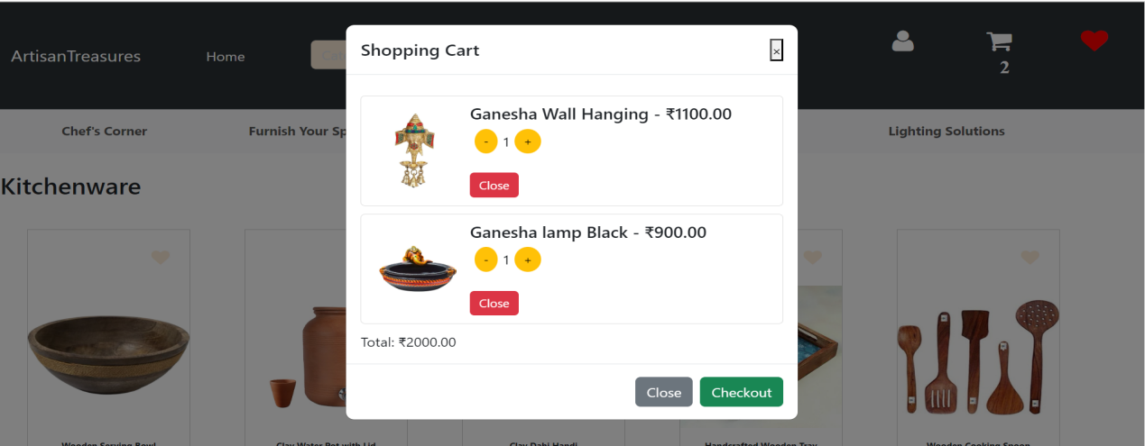

**Checkout:**

Finalize your order by providing shipping and payment details, reviewing your order, and confirming the purchase.

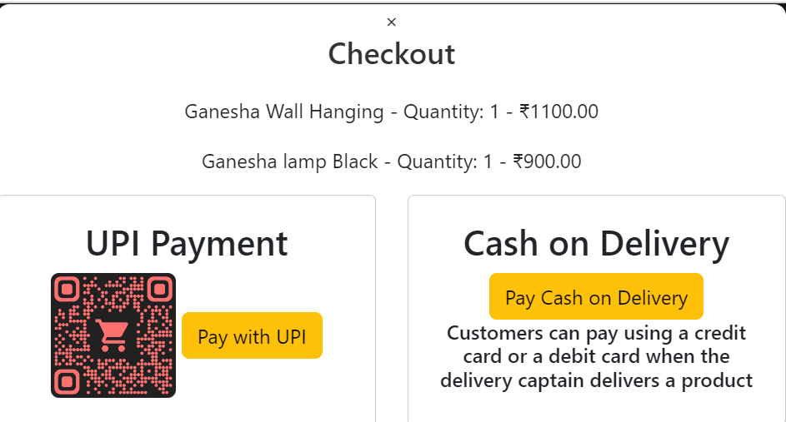

**PRODUCT PAGE:**

The Product Page is where users can view detailed information about a specific product they are interested in purchasing. It typically includes:

**Product Images:** High-quality images of the product from different angles.

**Product Description:** Information about the product's features, specifications, and benefits.

**Price and Availability:** The cost of the product and its current stock status.

**Buy now:** To buy the product.

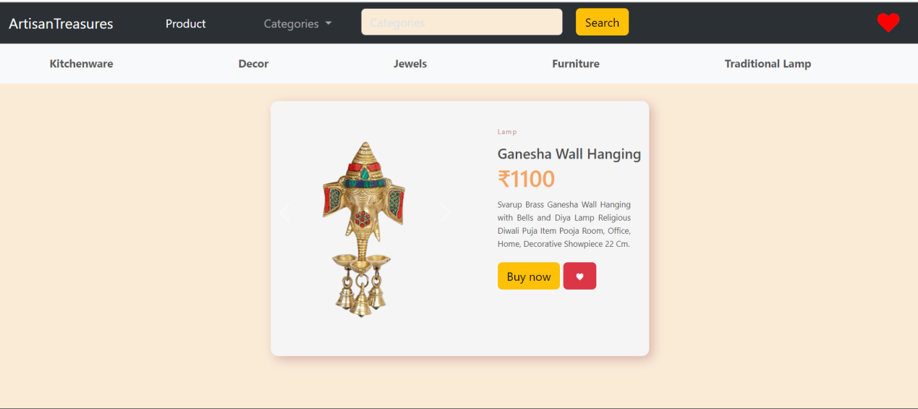

**After clicking buy now button:**

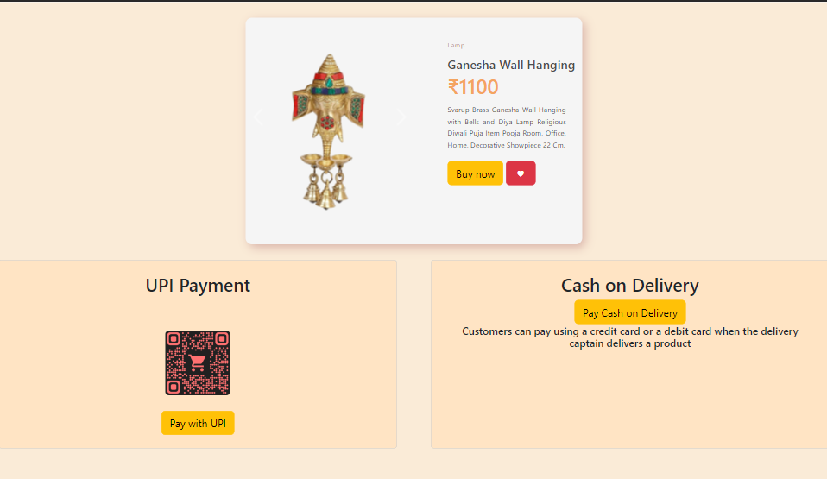

**Conclusion:**

The e-commerce project represents a significant milestone in our journey to create an efficient and user-friendly online shopping experience. From the project's inception, our goal has been to provide a seamless and secure platform for customers to browse, purchase, and receive products with ease.

Throughout the development process, we've employed a customer-centric approach, ensuring that the website meets the needs and preferences of our target audience. Extensive market research, thoughtful design, and rigorous testing have all played crucial roles in shaping the platform's layout and features.

The technical implementation of the platform has been robust, leveraging the latest web technologies to deliver a fast, reliable, and secure online shopping environment. We've prioritized the integration of payment gateways, inventory management, and a responsive design to adapt to various devices.

In conclusion, this e-commerce project reflects our commitment to providing a top-notch shopping experience, and we look forward to continued growth and success in the ever-expanding world of online retail.